Q1. Figure 1 shows a liner-elastic three-bar system. Please use Direct Stiffness Method to
1) Derive the element stiffness matrix. 20 points
2) Calculate the displacements at the end of each bar and fill the values into the table: 30 points
Node | 1 | 2 | 3
Displacement (U_mag). m | $$1∙{10}^{-8}$$ | $$3∙{10}^{-8}$$ | $$4.333*{10}^{-8}$$
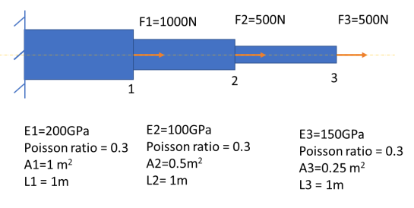
$$\frac{A_{1}E_{1}}{L_{1}}\left[\begin{matrix}1 & -1 \\ -1 & 1\end{matrix}\right]\left\{\begin{matrix}u_{1} \\ u_{2}\end{matrix}\right\}=\left\{\begin{matrix}F_{1} \\ F_{2}\end{matrix}\right\}→\frac{A_{1}E_{1}}{L_{1}}=\frac{200*{10}^{9}Pa*1m^{2}}{1m}=200*{10}^{9}$$
$$\frac{A_{2}E_{2}}{L_{2}}\left[\begin{matrix}1 & -1 \\ -1 & 1\end{matrix}\right]\left\{\begin{matrix}u_{2} \\ u_{3}\end{matrix}\right\}=\left\{\begin{matrix}F_{2} \\ F_{3}\end{matrix}\right\}→\frac{A_{2}E_{2}}{L_{2}}=\frac{0.5*100*{10}^{9}}{1}=50*{10}^{9}$$
$$\frac{A_{3}E_{3}}{L_{3}}\left[\begin{matrix}1 & -1 \\ -1 & 1\end{matrix}\right]\left\{\begin{matrix}u_{3} \\ u_{4}\end{matrix}\right\}=\left\{\begin{matrix}F_{3} \\ F_{4}\end{matrix}\right\}→\frac{A_{3}E_{3}}{L_{3}}=\frac{0.25*150*{10}^{9}}{1}=37.5*{10}^{9}$$
$${10}^{9}*\left\{\begin{matrix}200 & -200 & 0 & 0 \\ -200 & 200+50 & -50 & 0 \\ 0 & -50 & 50+37.5 & -37.5 \\ 0 & 0 & -37.5 & 37.5\end{matrix}\right\}\left\{\begin{matrix}u_{1} \\ u_{2} \\ u_{3} \\ u_{4}\end{matrix}\right\}=\left\{\begin{matrix}0 \\ 1000 \\ 500 \\ 500\end{matrix}\right\}$$
Cross these out because Node 1 will not move because of the Boundary condition keeping it in the same location.
$${10}^{9}\left[\begin{matrix}200 & -200 & 0 & 0 \\ -200 & 250 & -50 & 0 \\ 0 & -50 & 87.5 & -37.5 \\ 0 & 0 & -37.5 & 37.5\end{matrix}\right]\left\{\begin{matrix}u_{1} \\ u_{2} \\ u_{3} \\ u_{4}\end{matrix}\right\}=\left\{\begin{matrix}0 \\ 1000 \\ 500 \\ 500\end{matrix}\right\}$$
$${10}^{9}\left[\begin{matrix}250 & -50 & 0 \\ -50 & 87.5 & -37.5 \\ 0 & -37.5 & 37.5\end{matrix}\right]\left\{\begin{matrix}u_{2} \\ u_{3} \\ u_{4}\end{matrix}\right\}=\left\{\begin{matrix}1000 \\ 500 \\ 500\end{matrix}\right\}Element stiffness matrix$$
Using trivial MATLAB code to solve this matrix we can find that the results are:
A=[250,-50,0;-50,87.5,-37.5;0,-37.5,37.5];
B=[1000;500;500];
x=A\B
$${10}^{9}\left[\begin{matrix}250 & -50 & 0 \\ -50 & 87.5 & -37.5 \\ 0 & -37.5 & 37.5\end{matrix}\right]\left\{\begin{matrix}u_{2} \\ u_{3} \\ u_{4}\end{matrix}\right\}=\left\{\begin{matrix}1000 \\ 500 \\ 500\end{matrix}\right\}→\left\{\begin{matrix}u_{2} \\ u_{3} \\ u_{4}\end{matrix}\right\}=\left[\begin{matrix}\left(\frac{10}{{10}^{9}}\right) \\ \left(\frac{30}{{10}^{9}}\right) \\ \left(\frac{43.333}{{10}^{9}}\right)\end{matrix}\right]$$
Verifying our results with ABAQUS, we get:
Node Label U.Magnitude
@Loc 1
--------------------------------
1 0.
2 10.000E-9
3 30.000E-9
4 43.333E-9

Q2. Please build a FE model to analyze the stress distribution and displacement in the following truss setup (E=2.0E+11Pa, A=1m2 , Poisson ratio=0.3):
1) Create a short report in PDF or Word format to display the Von Mises stress and the magnitude of displacements 20 points
2) Extract the displacement values for N1, N2 and N3 and fill in the following table: 20 points
Node | U_mag, m | U_1, m | U_2, m
N1 | 2.77565E-09 | 915.063E-12 | 2.62047E-09
N2 | 1.83013E-09 | 1.83013E-09 | -183.012E-36
N3 | 7.51075E-09 | 7.03878E-09 | 2.62047E-09

3) Save and upload the FE model 10 points
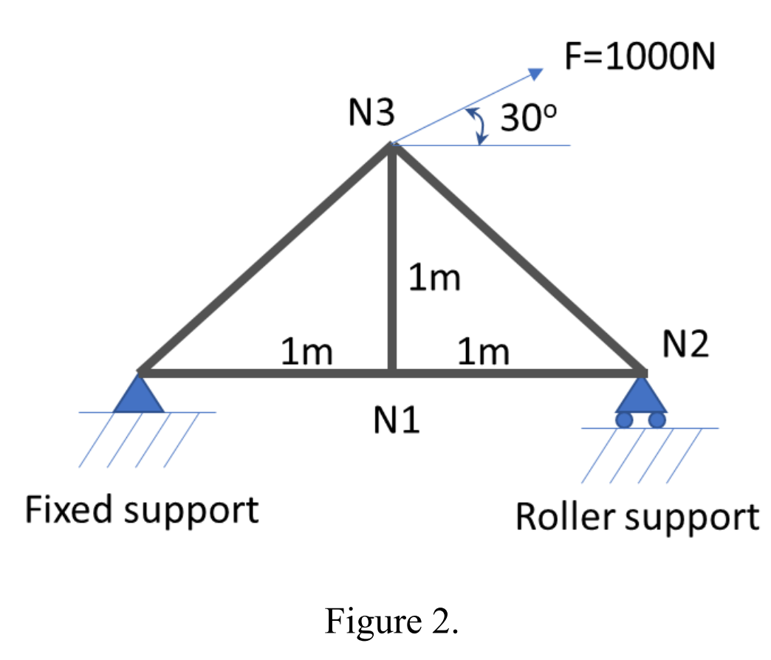

Mises and Magnitude:
**********************************************************************
Field Output Report, written Sat Feb 5 13:41:35 2022

Source 1
---------

ODB: C:/Users/User/Desktop/HW1P2/HW1P2Job2.odb
Step: ApplyLoadAndBC
Frame: Increment 1: Step Time = 1.000

Node Label U.Magnitude S.Mises
@Loc 1 @Loc 1
------------------------------------------------
1 2.77565E-09 122.008
2 1.83013E-09 220.916
3 7.51075E-09 408.248

